**LIGHTING EFFECT**

1. BACKGROUND COLOR- BLACK
2. CREATE LAYER----- MAKE A SHAPE (LIGTING TYPE) – WITH YELLO COLOR
3. SELECT DODGE TOOL (FROM TOOLS) – (50 SIZE/HIGHLIGHT/RANGE)--- SIDE AND THAN USE BURN TOOL INSIDE OR CENTER OF SHAPE
4. FOR SMOKE---- GOTO FILTER-DISTORT- WAVE

GEN--- 5 WAVELENGTH -- 10-120

AMP 5 TO 35

SCALE 100 TO 100

6 EDIT – FADE WAVE (50%)

REPEAT IT MANY TIMES

**OCEAN LIGHTING EFFECT**

1. **SKYBLUE COLOR ON BACKGROUND SHEET**
2. **FILTER--- RENDER--- CLOUD**
3. **FILTER ----- DISTORT --- RIPPLE (LAYER 999%)**
4. **FILTER ---- DISTORT --- OCEAN RIPPLE**
5. **FILTER ---- RENDER--- LIGHTING EFFECT**

|  |
| --- |
| **OMNI**  **INT =36**  **GLASS =27**  **MAT=40**  **EXP =7**  **AMB=29** |

1. **LAYER --- STYLE - COLOR OVERLAY (33%)**

**Use all style inside button in ocean light /twirl**

**GLAXY**

New Layer - 1500 * 1500 Px with black color

1st Layer - white color --- blending option – drop shadow-- dissolve---1% -- ok

Create 2nd layer – Brush = 100% opacity 125 px diameter – white color-- draw a nebula

Filter- distort—twirl 999%

Edit---- Transform—Perpestive

Edit --- Transfer--- Scale

Blur--- Filter

**STAR SHINING**

**BACKGROUND ----- BLACK COLOR**

**1st LAYER - Black Color**

**Filter--- Render- Lens Flare – Ctrl +t (Size small)**

**Ctrl+j (duplicate) like as a star (4 Time)**

**Merge all layer Ctrl+Shift+E**

**Unlock Background Layer (Double clik in Lock)**

**Filter—Distort+Wave**

|  |  |
| --- | --- |
| **Gen--------155**  **Wave = 752 to 799**  **Amp = 6 to 59**  **Scale = 100 to 100** |  |

**Extra function**

**Filter- Distort- Twirl or zigzag**

God background

**New layer 300*300 pixal**

**1ST Layer – black color**

**Render -- Cloud**

**Filter-------- Pixlet------------ Mezztint (Fine Dots) -**

**Filter ---- Blur ------ Redial Blur (90-100, Zoom, Best)**

**Extra**

**Image-------- Adjustment --------- Invert**

**Radial Blur----- 2 Times (90-100, zoom, Best) third Time (5-6,spin,best) 4th Time (90-100, zoom,best)**

**Image- adjustment- layer**

**Or extra**

**Blending option – color overlay- blue color- check adjustment and opacity**

**Filter---- sketch--- chrome/plastic (All Function)----- Right click- Blending Option—do all function**

**Text FIRE**

CTRL+N == NEW FILE 3*3 INCH / Resolution =300/ White color background

Drop black color on Background sheet

Click on T ==== then Type anything (AICT) and adjust Text on sheet

Create Duplicate text layer by Ctrl+j(Duplicate ) and hide it

Click on original text - --- Goto to Image --- click on Rotate (90Degree CW)== it show vertical your text

Filter--- Stylize- wind ( wind ok, right or left select as your choice)

Repeat it ------------ then rotate text

Creat a Duplicate Layer of Background sheet

Merge original Text with Background layer by CTRL+E

Filter------- Liqifiy

Image -------- Adjustment------ Hue & Saturation (Click on Colorize buttion and use up and down number)

Unhide the text and adjust it on fired text

**SLICE TOOLS**

NEW FILE

WINDOWS – LAYERS

Create new layer - RECTANGLE SEELCTION- FEATHERS 5 – WINDOWS—STYLES – ALT+BACKSPACE

THAN TYPE MATTER ON RECTANGLE

THAN SELECT BY SLICE TOOL OF RECTANGLE / SELECT SLICE TOOLS/ (FOR CHANGE SLICE SIZE)

RIGHT CLICK ON RECTANGEL - SLICE OTPION – FILL THE INFORMATION--- OK

FILE --- SAVE ( HTML AND IMAGES SELCTION HONA CHAHIYE)

THAN GOTO DESKTOP (WHERE UR FILE SAVED) --- CLICK ON FILE – ITS SHOW HYPERLINK ON YOUR RECTANGLE

**FIRE EFFECT**

FILE –---- NEW-------------800*600

D=FOR BLACK AND WHITE COLOR

FILTER =======RENDER ==CLOUD

BRUSH==BLACK COLOR===HALF SIDE FROM TOP

FILTER ==LIQUIFY------------CREATE FIRE EFFECT === OK

IMAGE ===GRAYSACLE ==OK

IMAGE==INDEXED

IMAGE ===COLOR TABLE ==BLACK BODY

IMAGE IN CUSTOM SHAPE

* OPEN NEW FILE
* OPEN PHOTO
* DRAW A CUSTOM SHAPE ON NEW PAGE FOR SELECT SHAPE CTRL+ENTER
* COPY PHOTO
* THEN CLICK ON NEW PAGE == EDIT == PASTE INTO

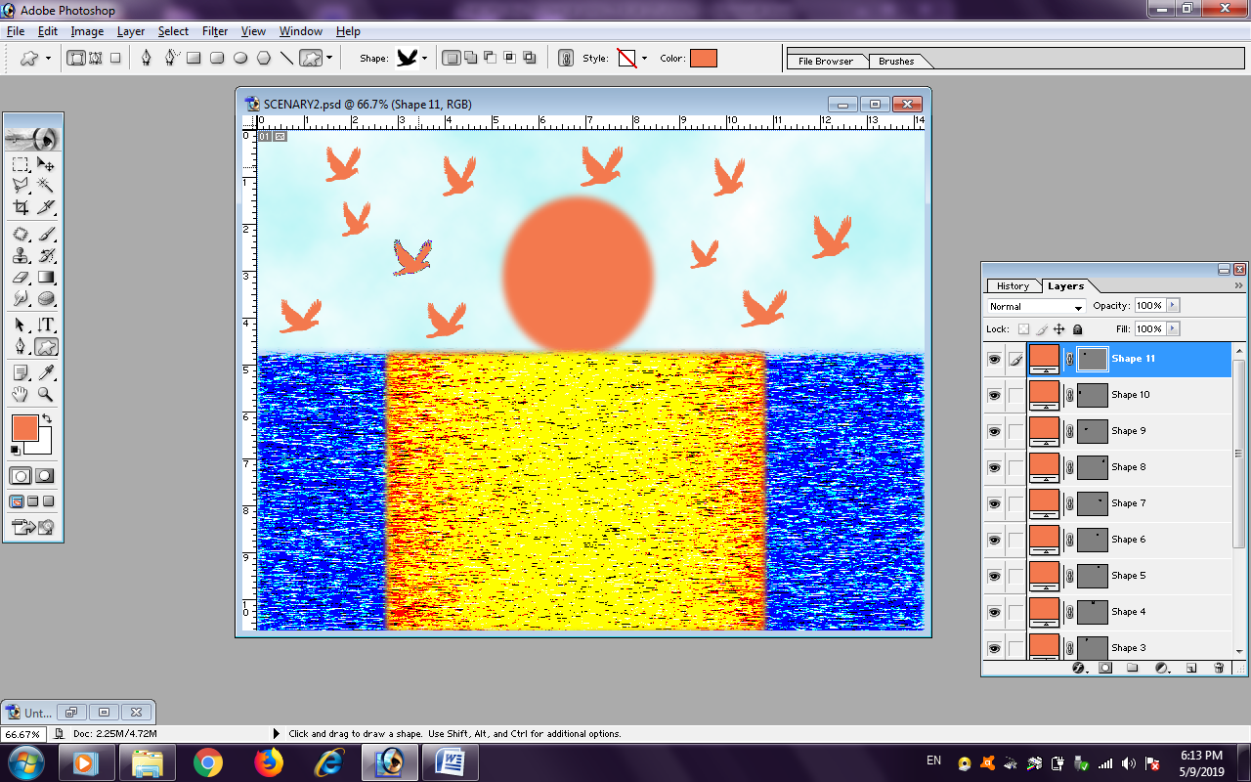**SCENARY CREATE**

* NEW FILE == FILTER === RENDER === CLOUD (BLUE COLOR/ WHITE COLOR) (BACKGROUND SHEET)
* HALF BOX BY RECTANGE FROM BOTTOM OF PAGE == DROP BLUE COLOR
* FILTER ==PIXLATE == MEZOTINT == SHORT LINE =OK
* CREATE NEXT LAYER == CREATE A CIRCLE == FILL COLOR
* CREATE A BOX = YELLOW COLOR == FILTER == PIXLATE == MEZOTINT== SHORT LINE= OK
* THAN GOTO CUSTOM SHAPE == BIRD

**Overlay effect on photo & scenary**

* Open a scenery
* Open a photo
* Select photo by magnetic lasso tools == goto select option == feather (5) == ok
* Ctrl+c and than paste on scenary photo
* Than run effect by layer button and also opacity

**LIGHTING EFFECT ON PHOTO**

**OPEN PHOTO**

**FILTER – RENDER === LIGHTING EFFECT**

**CD WRITING EFFECT**

**OPEN BLANK PAGE**

**LAYER 1 = CREATE A CIRCLE WITH GRAY COLOR**

**LAYER 2 = CREATE A CIRCLE WITH BLACK COLOR (SMALL THAN OLD CIRLCE)**

**THAN DRAGE OR COPY TWO PHOTO (IT AUTOMATICALLY LAYER 4 AND 5 LAYER5)**

**ADJUST PICTURE ON TOP OF BLACK CIRCLE**

**CTRL + ALT + G = ADJUST PIC ON DOWN LAYER**

**LATER 3 = CREAT A CIRCLE WITH WHITE COLOR ( SMALL CIRCLE JUST LIKE IN CD)**

**CHOCLOTE EFFECT**

* OPEN NEW FILE
* CREATE NEW LAYER === CREATE A RECTANGLE == FILL CHOKLATE COLLOR ON RECTANGLE
* RIGHT CLICK ON FIRST LAYER == BLENDING OPTION == BEVEL & EMBOSS (CREATE CHOCKLATE SETTING)
* ALT+ DRAG ON CHOKLATE == CREATE DUPLICATE LAYER = SET THE ALL CHOCKLATE SHAPE

**COLOR DESIGN/ROUND/CIRCLE DESIGN**

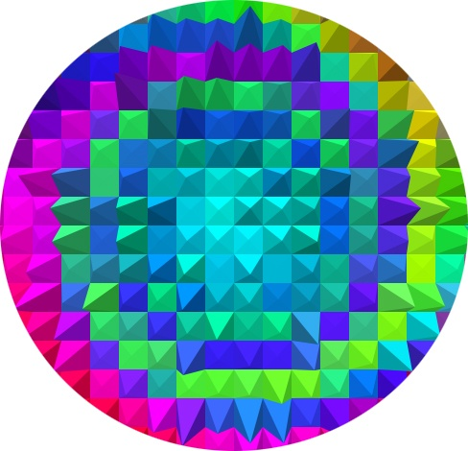**NEW LAYER -- CIRCLE-- GRADIENT TOOL**

**FILTER------ DISTORT – TWIRL**

**CTRL+d = UNSELECT**

**FILTER- STYLIZE – EXTRUDE/POLAR AND**

**USE MANY OTHER FUNCATION**

**EYE COLOR/ LIPS COLOR/HAIR COLOR**

**PIMPLE WORK == PATCH TOOLS**

**OPACITY EFFECT ON PHOTO**